 **TankMatic**

Installation and Operation Manual

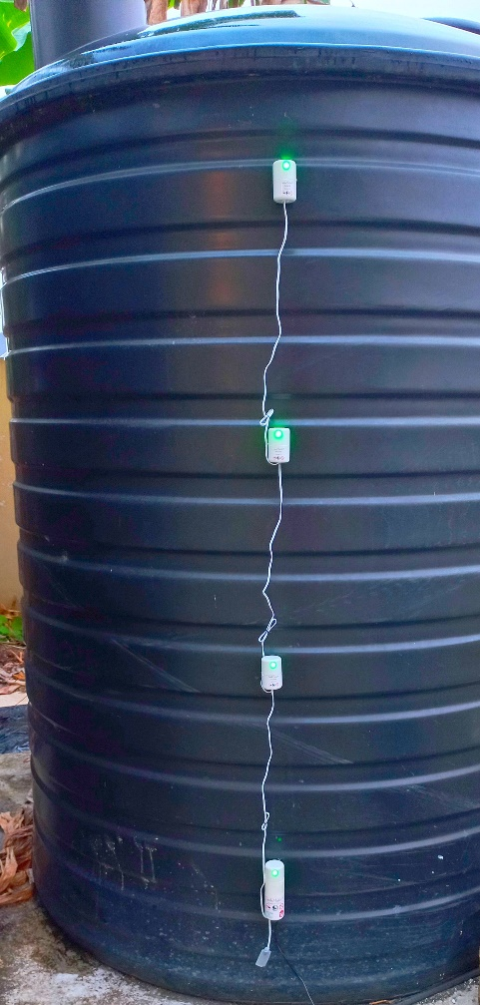

Date: March 2025

Contents

1 Comparison of Products and Technologies - 3 -

2 Prerequisites - 6 -

2.1 Tools - 6 -

2.2 Site resources - 6 -

2.3 Kit contents - 6 -

3 Connect the product to the WiFi network - 7 -

3.1 Power up - 7 -

3.2 Enter WiFi credentials - 7 -

3.3 Find the product’s profile in Telegram - 8 -

3.4 Notifications - 9 -

3.4.1 Add or remover Users - 9 -

3.4.2 Enable or disable notifications - 9 -

4 Installation onto the Tank - 10 -

4.1 Mark and clean the external wall - 10 -

4.2 Install the components - 11 -

4.3 Powering - 12 -

5 Calibration and General Use - 13 -

5.1 Calibration - 13 -

5.2 Use - 13 -

List of Abbreviations

* IP - Internet Protocol
* SPin - SuperMation Products identification number
* UI - User Interface

# Comparison of Products and Technologies

|  |  |  |
| --- | --- | --- |
| TankMatic Models | | |
| Item | L series | R series |
| Calibration and sensitivity | Fixed. | Variable sensitivity and calibration via software. |
| Visual Indicators | Multicolour LED:   * Green for water detected * Blue for no water. * Orange for device connected or hardware fault. | Multicolour LED:   * Green for water detected * Yellow for no water. * Purple for wireless connection. * Blue for configuration mode. * White for calibration and remote updates. |
| UI and remote access | None. | Via phone browser through local WiFi network. Remote access using the Telegram app. |
| Weather resistant | Yes. | |
| Relative cost | $ | $$ |
| Additional sensors | An extra 4 sensors can be accommodated via a separate expansion string. | No. |

| Technologies | | |
| --- | --- | --- |
| Item | TankMatic | Ultrasonic |
| Calibration setup | None for L model.  Rapid calibration for R model with remote calibration capability through SPL. | Required for each tank installation. Full (100%) through to empty (0%) readings are based on the distance of the tank’s top from its base. |
| Calibration drift | None. | Requires temperature compensation. |
| Tank integrity for installation | Not affected. | Drilling/cutting a hole in the top of the tank is needed for the sensor. |
| Installation time | Approximately 15 minutes for the L model.  Approximately 30 minutes for the R model. | Approximately 30 minutes. |
| Reading resolution | 5 levels (100%/75%/50%/25%/Critical) with 4 sensor string. | 100% to 0% continuous reading. |
| Reading stability | Less affected by water slosh when tank is filling.  Not affected by temperature.  Heavy rains may give false positive with the L model. | Significantly affected by water slosh and temperature.  Not affected by rainfall. |
| Water contamination during installation | Not possible. | Contents of the tanks will be exposed during installation. Possibility of debris falling into the tank. |
| Service life | Long life due to electronics sealed and not exposed directly to the weather. | The sensor is continuously exposed to moisture inside the tank which may affect longevity. |
| Subscription fees and advertisements | None. | Depends on the app. |
| Visual indicators on the tank | Yes. | Typically none. |
| UI, remote access. | Yes (R model). | Yes, dependent on the app. |
| Standalone capability without the internet. | Yes. | Depends on the app. |
| Additional sensors | 4 extra sensors can be accommodated on the L model. | Not required as the single sensor provides a readings from full to empty at high resolution. |

# Prerequisites

Safety is crucial so please ensure proper safety rules and use of tools are followed. The details of these are outside the scope of this document. SuperMation Products Limited is not liable for any injuries or damages incurred due to incorrect installation.

## Tools

Before installation, ensure the following tools are available:

1. Hot glue gun (minimum 60Watt) for full size (11mm or 0.43inch) sticks.
2. Extension cord (length depends on the location of the target tank and nearest power receptacle).
3. Ladder or scaffolding for tanks installed at significant height.
4. Clean, lint-free, cloth and rubbing alcohol in a spray bottle.

## Site resources

The following are needed for the installation at the tank:

1. One available 120VAC power receptacle. For the L model, please ensure the house wiring is properly grounded (poor grounding will prevent the product from detecting water). A simple test is to measure the AC voltage at the receptacle between neutral and ground (use certified personnel and instrument). There must be 0.00V as shown in the picture below. Even a small voltage, for example 0.05V, will cause the product to not function properly.

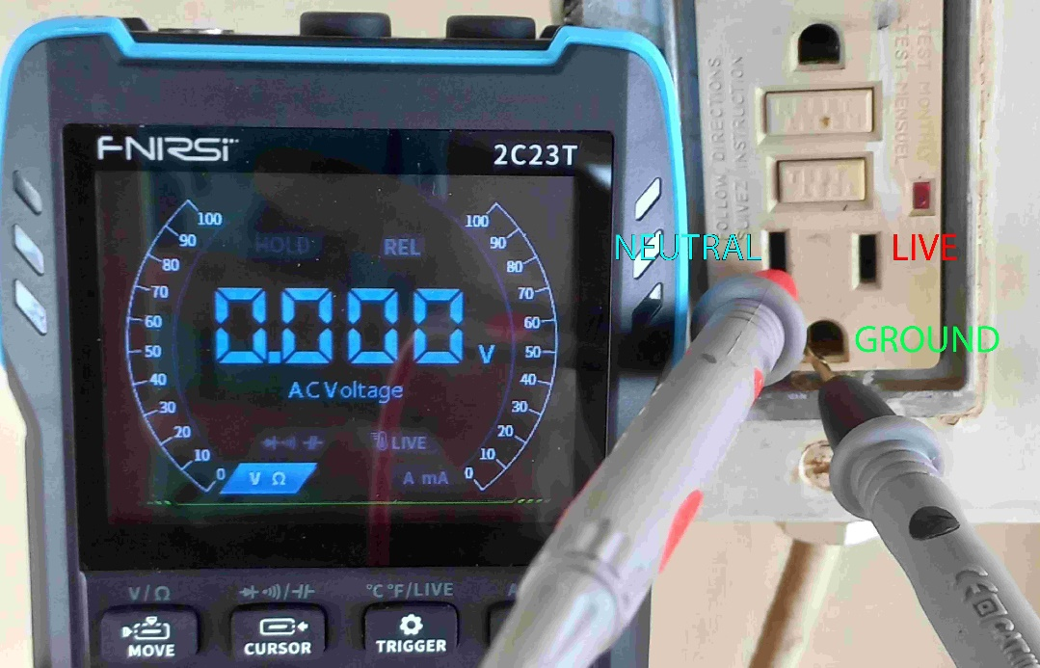

1. R model only: WiFi 2.4GHz network (signal strength should be -60dBm or stronger). Internet for remote access and notifications. This is optional but recommended for the best user experience and remote diagnostics by SuperMation Products Limited.
2. The tank outer surface must be dry with no trace of moisture. Please do not install in drizzle/rain.

## Kit contents

The kit contains all that is needed for a full installation as listed below:

1. One TankMatic hub.
2. Three TankMatic sensors, (S1, S2, S3 labeled for the R model).
3. One power cord 18foot long.
4. One hot glue stick 11mm x 270mm.
5. QR code stickers for the UI and Telegram profile (R model only).

# Connect the product to the WiFi network (R model only)

This section shows how to use the product in normal mode with connection to a router.

## Power up

Insert the 2 prong power plug into a 120VAC receptacle, preferably within 10 feet of the WiFi router. To test the detection capability, place your hand behind the LED. This is the sensor area. The led will turn green with contact to your skin and yellow when not.

## Enter WiFi credentials

It will flash purple for approximately 20 seconds then blue flashes for 120 seconds. This pattern will repeat until it successfully connects to a router. The blue flashes indicate it is in configuration mode. Use your phone to connect to its private network:

SSID: SPL_network_TM* (the * is a number which varies depending on the SPin)

Password: 1234567890

Once connected, scan the QR code in the kit or the below QR code (this works only when connected to the R model private network):



The simple UI will load as in the example (when installed onto a full tank):

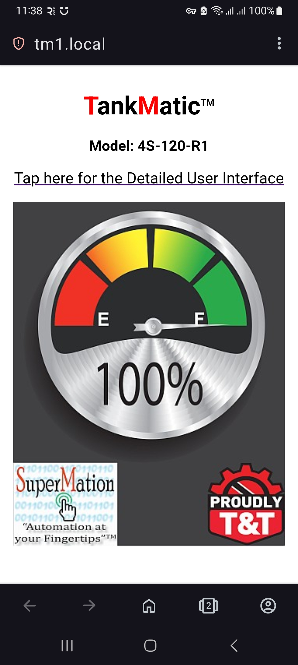

Tap on the link to go to the Detailed UI, tap on the About tab then scroll down to the WiFi credentials section (the purple rectangle shows how many seconds remain until the product restarts):

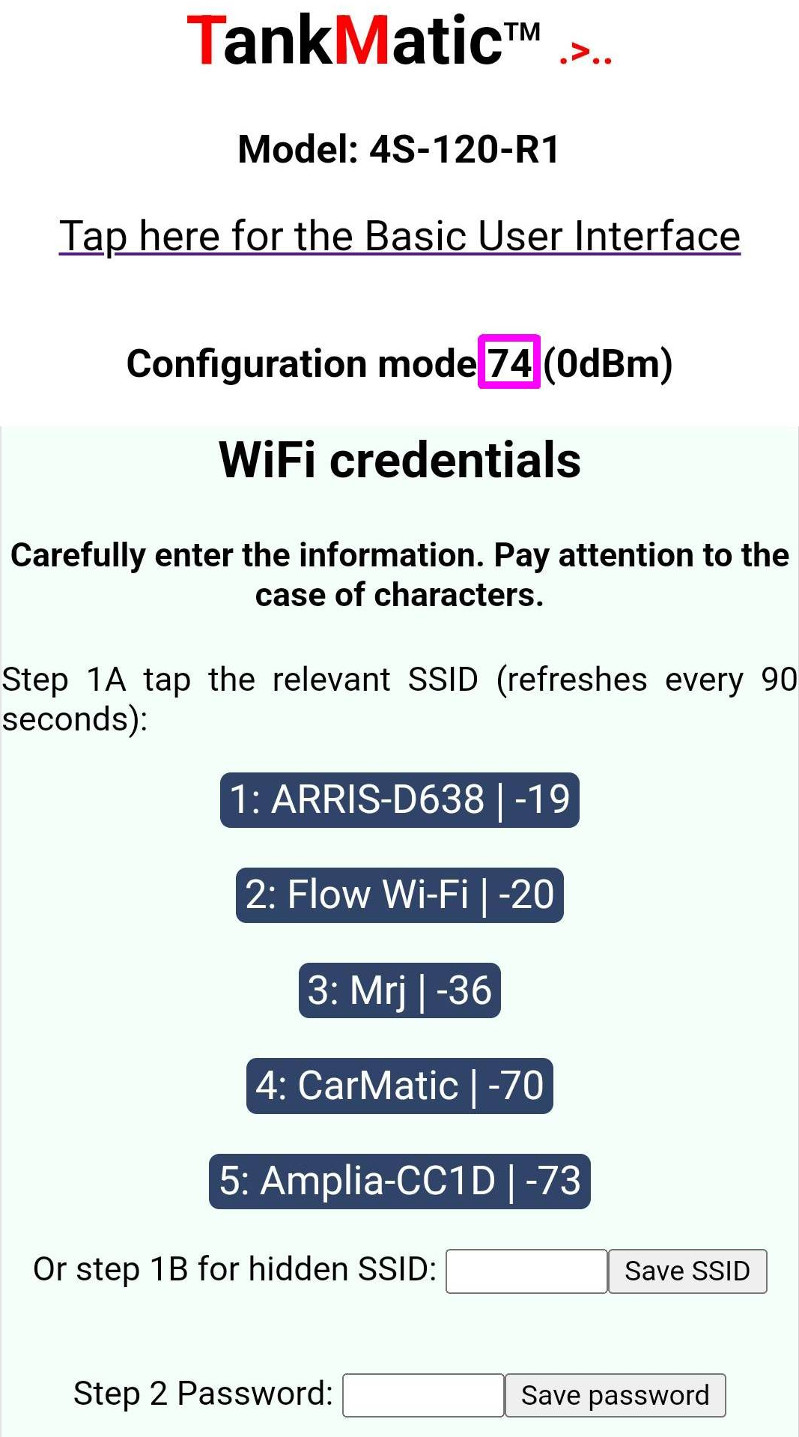

There are 5 buttons showing the discovered SSIDS followed by their signal strength in dBm (the strongest signal is at button 1). Tap the button of the relevant SSID or enter your hidden SSID manually, tap the Save SSID button, then tap the back button on your phone. Enter the relevant password then tap the Save password button. The product will restart into normal mode. It will flash purple several times. If the credentials are correct and the router accepts the product, the light will turn yellow or green.

If the product did not connect successfully, repeat this sub-section (3.2) and carefully re-enter the credentials.

## Find the product’s profile in Telegram

Use the provided sticker and scan the QR code to add the product to your chat list in Telegram. Tap the Start button and then enter the product’s SPin. The keyboard menu will now be visible. Do not share this information with unauthorized individuals. The sales agreement does not cover reprogramming of the product.

## Notifications

### Add or remover Users

While connected to the WiFi router, scan the nameplate QR code. If using an Android phone, you may need to wait approximately 5 minutes before this address resolves. A faster method is to tap the Details button in the Telegram chat keyboard: the address will be shown in blue text (see example below). Please bookmark both the QR code and numerical IP addresses in your browser app.

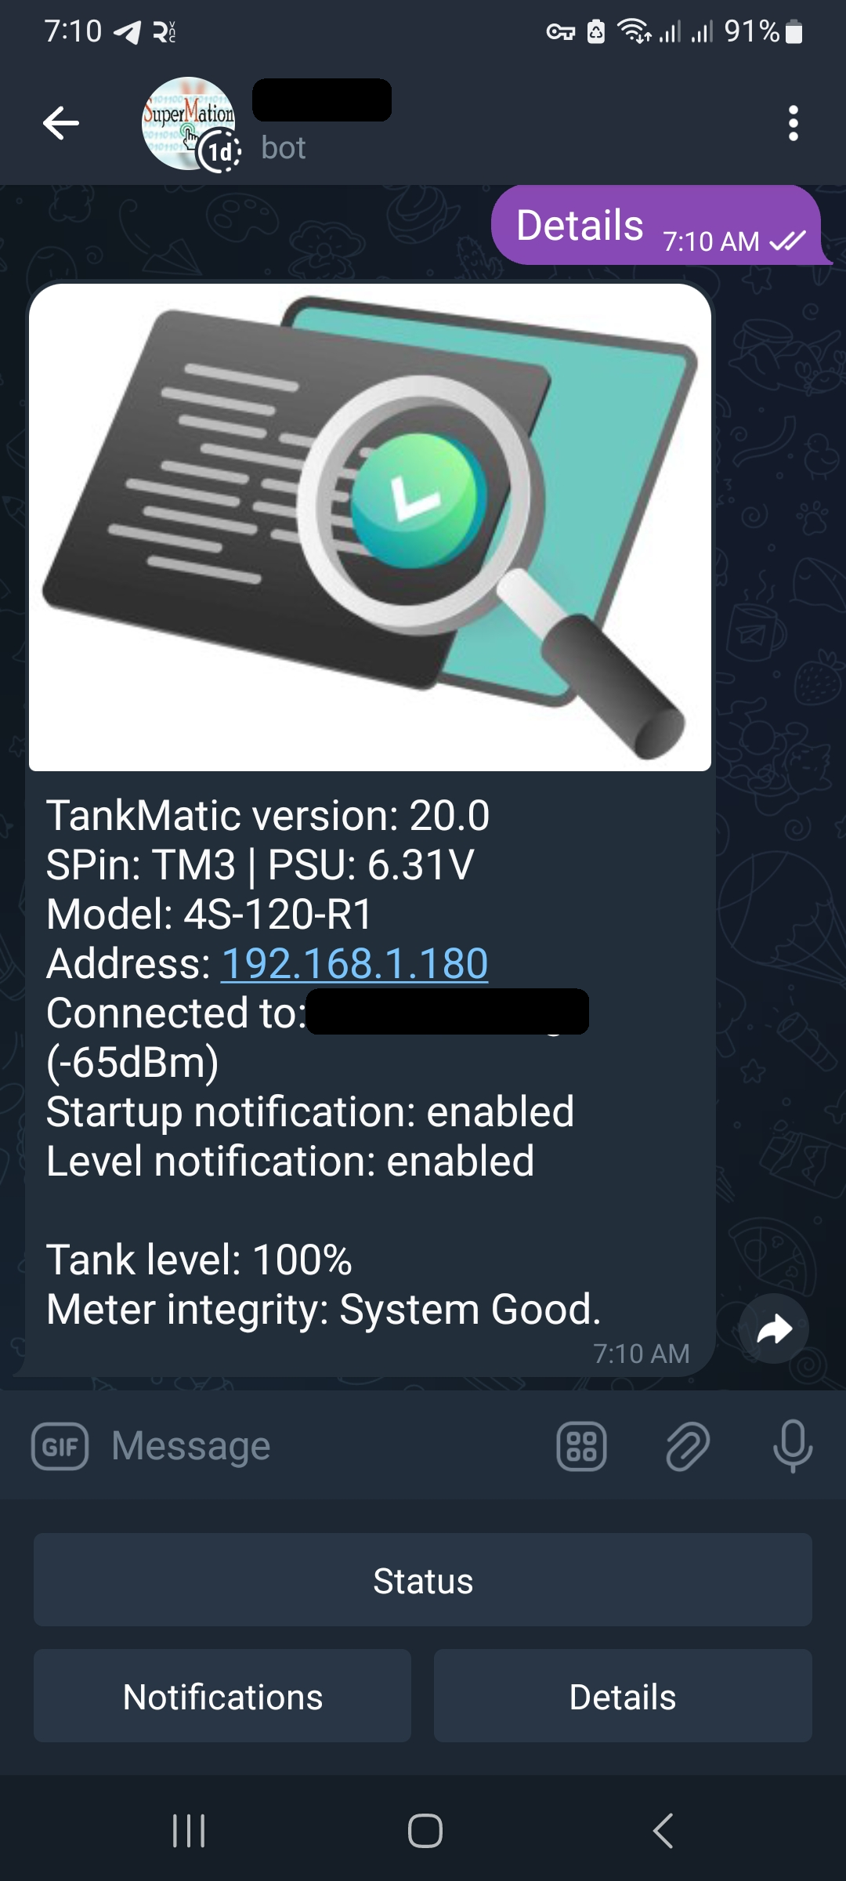

In the detailed UI (see sub-section 3.2), in the Control tab scroll down to the Notifications via Telegram section.

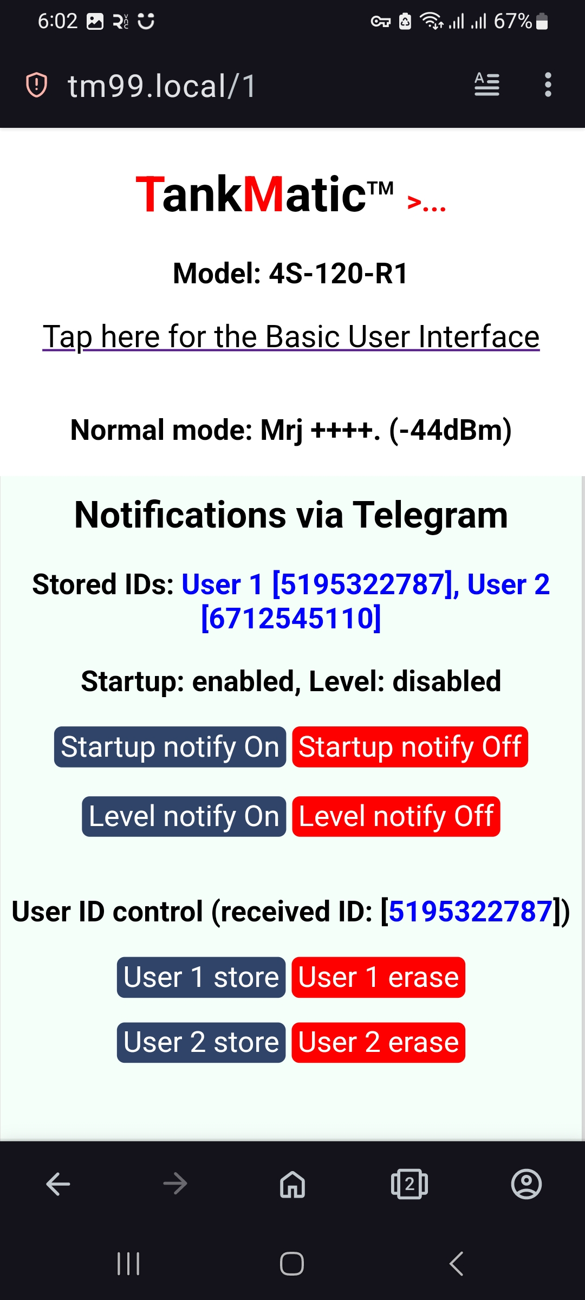

In Telegram tap the Status button, wait for a response and tap User 1 store button. A second user can be added by sharing the Telegram program, entering the SPin, tapping the Status button and tapping User 2 store button.

Either user can be removed by tapping the erase buttons and typing Yes and the prompt.

### Enable or disable notifications

In sub-section 3.4.1, tap on the Notify On/Off buttons to enable or disable the startup and level change notifications. Both are enabled by default. Also in the Telegram chat, tap on the Notifications buttons to perform the same functions.

# Installation onto the Tank

The product is designed for non-metallic liquid storage tanks. Ceramic, concrete and silicone tank walls are not compatible with the product. It is strongly recommended to install onto a full tank.

## Mark and clean the external wall

Most tanks are made as a ribbed structure as shown in the examples below.

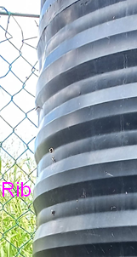 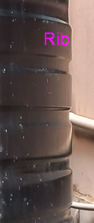

All components are installed on the ribs (or any part of the external surface for non-ribbed tanks).

The hub is the bottom component, the top of which should be placed 6 to 12 inches from the base of the tank. This volume of water is called the reserve.

Sensor S3 (or the topmost sensor for the L model) should be placed approximately 6 to 12 inches below the float valve inlet. This volume of water is called the buffer. The following photo shows a typical installation example.

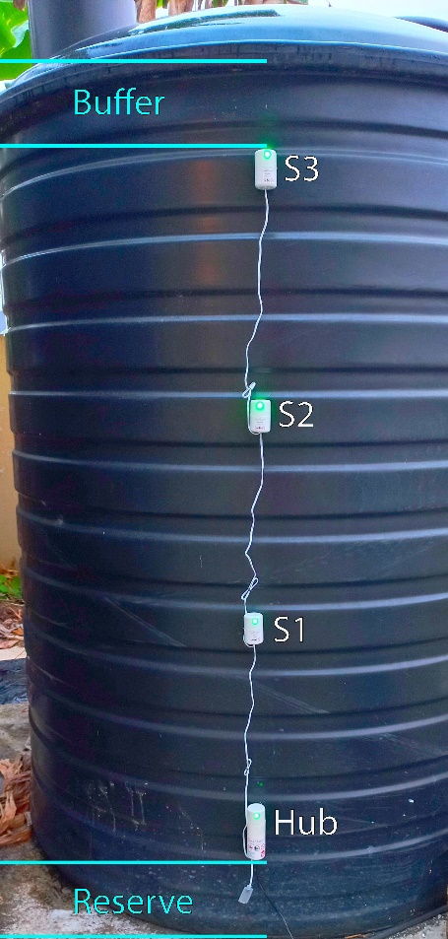

Sensors S1 and S2 need to be placed equally apart from the hub and S3. When all 4 locations are identified, clean thoroughly with rubbing alcohol. Please note the L model does not have sensor numbers.

## Install the components

Important! If the tank is not full then the water level must be accurately located. Sensors above the waterline need to be temporarily placed at a rib which is below the waterline. This will be important for calibration in section 5.1.

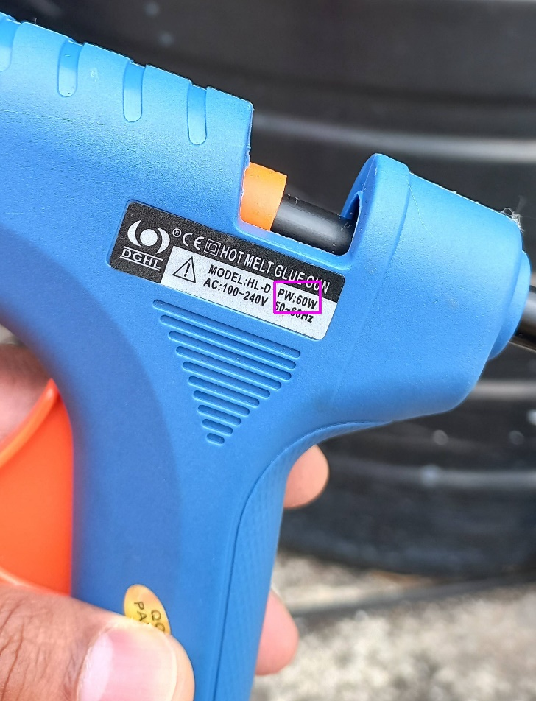

Ensure your hot glue gun is hot enough that some glue begins to flow from the nozzle. Starting at the base with the hub, apply a vertical 1 inch line of glue at the sensor area (directly behind the LED). Ensure the LED is oriented up and faces outwards. Firmly press the hub onto the cleaned tank surface and hold for 20 seconds. The hub must vertical (the wires at the bottom of its shell). If the installation was incorrectly done, spray the cooled glue with rubbing alcohol and let soak for 2 minutes. Pull off the hub and peel off traces of the glue. Repeat the installation properly.

Apply an inverted “U” of hot glue to seal the top of the shell to the tank and along the sides to a length of 1 inch. This ensures reliability of the product during rainfall. There is no need to glue the entire shell to the tank.

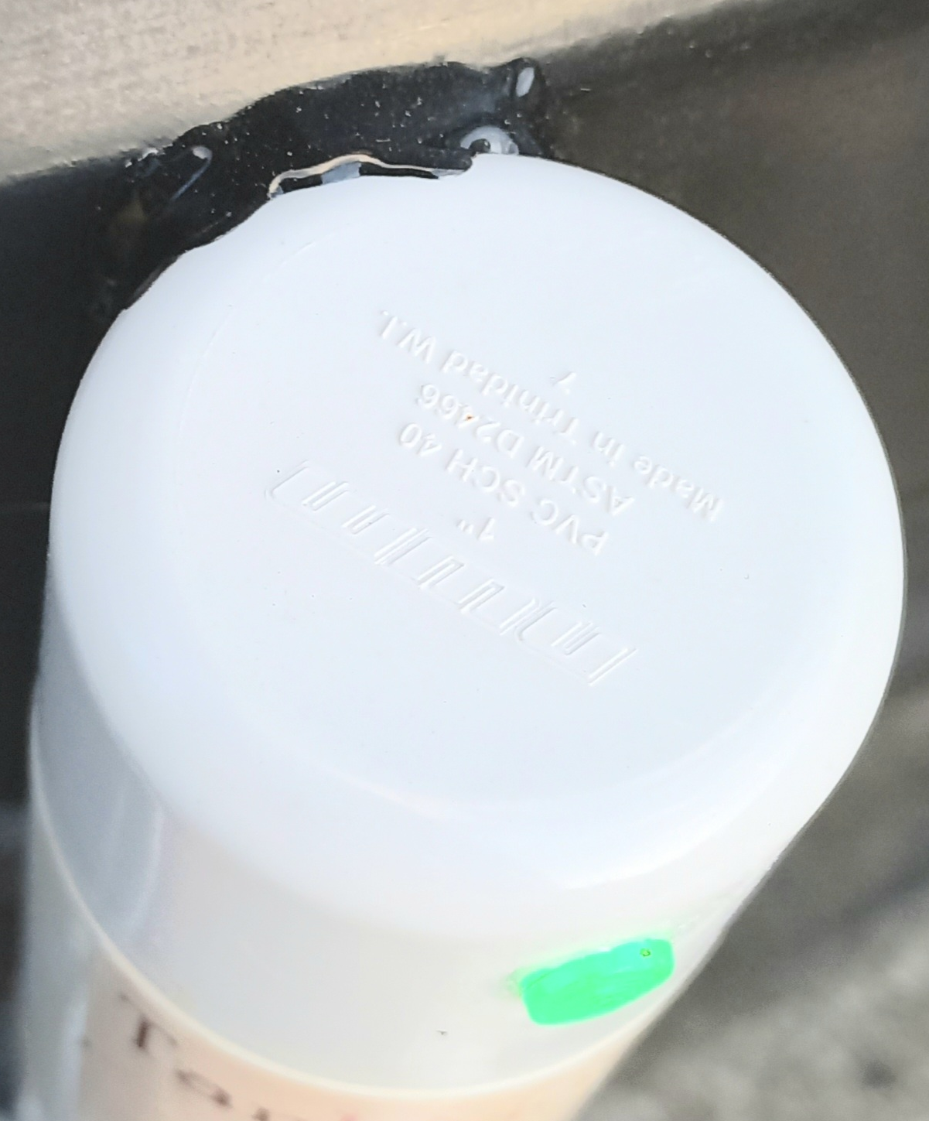 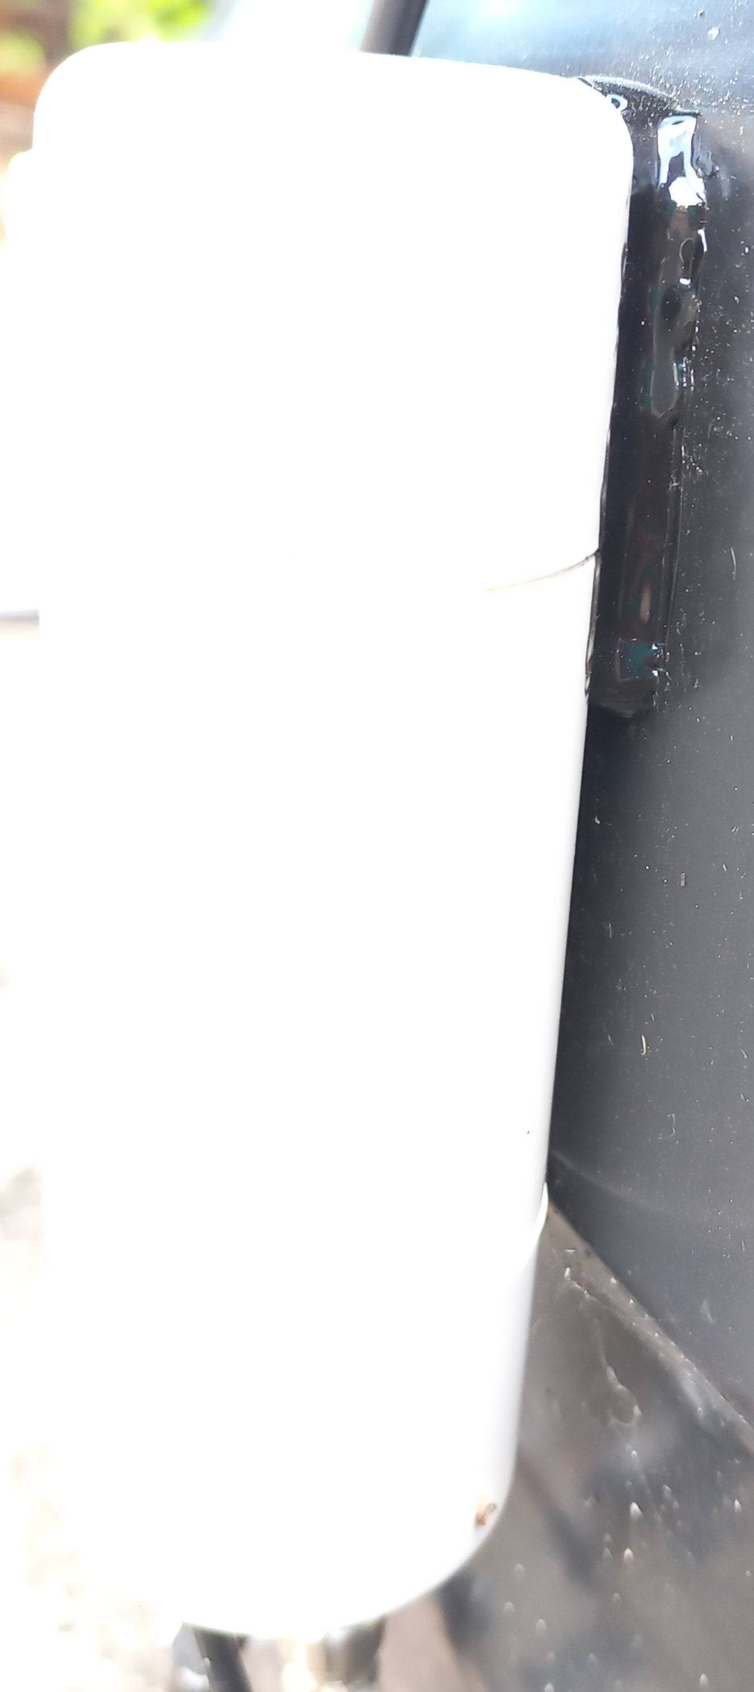

Apply the same technique to other sensors.

## Powering

The 120VAC two pin plug needs to be inserted into a nearby receptacle. Carefully run the cord to the 120VAC receptacle. You can use hot glue to secure the wire to the tank surface, pipes and concrete walls for example.

* R model: The 4 LEDs will go active. If S1/2/3 LEDs are purple, wait approximately 2 minutes for the system to self-configure. On a full tank, all 4 LEDs should be green. The hub LED will flash purple a couple times then turn green. At this time you should get a message from Telegram if you were added as a user for notifications. You should receive notifications in the Telegram app as the sensors read the water level. Tapping the status button will give the estimated water level. If the tank is partially full, at least one LED, starting from the top, will be yellow.
* L Model: Green indicates water is detected. Blue means no water at the level of the sensor.

# Calibration (R model only) and General Use

## Calibration (R model)

With the 4 components installed and powered on a full tank, calibration of the system is recommended. The product has default values for domestic polypropylene water tanks but calibration ensures consistent operation in dry and wet conditions.

If the tank is not full, do not perform the global calibration. Wait until the tank is completely full i.e. the float valve has shut off the water inside the tank.

In the detailed UI (see sub-section 3.2), in the About tab scroll to the bottom and tap on the Calibration and Configuration button, the password requested is SPL. Tap the Global Calibration button, type Yes and tap OK. The hub LED will go white for several seconds and S1/2/3 LEDs will flash white. At the end of calibration the LEDs will go green. The product is ready for use.

## Use

The R model can be accessed locally via its UI on your phone browser app or remotely using the Telegram app.

The L model will provide a light colour depending on the presence of water within the tank. See the first table in section 1.

## Troubleshooting

The R model WiFi performance may be affected by pumps that cycle more than 5 times a minute. Fast cycling is a symptom of a water leak or fault check valve. Please consult a plumber to fix this issue.

Heavy rainfall may cause the L model to falsely indicate the presence of water when no water is at the sensor(s). When the tank outer surface dries, the product will properly detect the internal level.